Featured Projects 🡪

1. The IceHouse Development

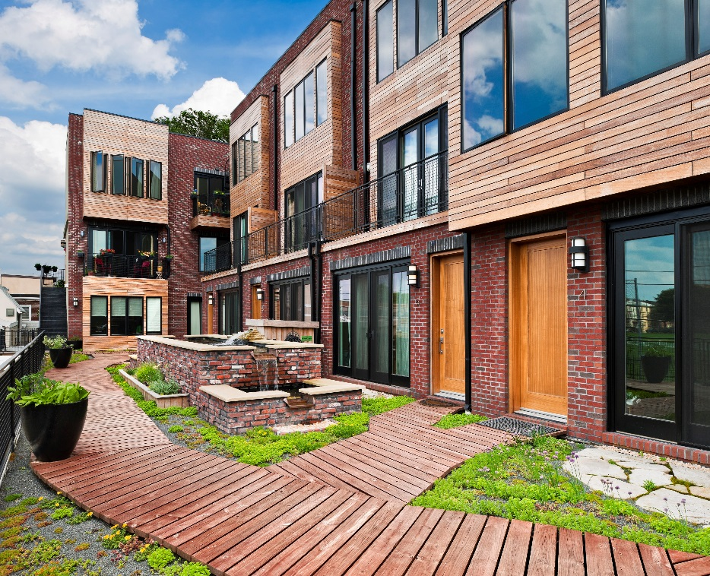

* Clicking picture leads to website - <http://www.theicehousedevelopment.com>

1. Moyer Street Court

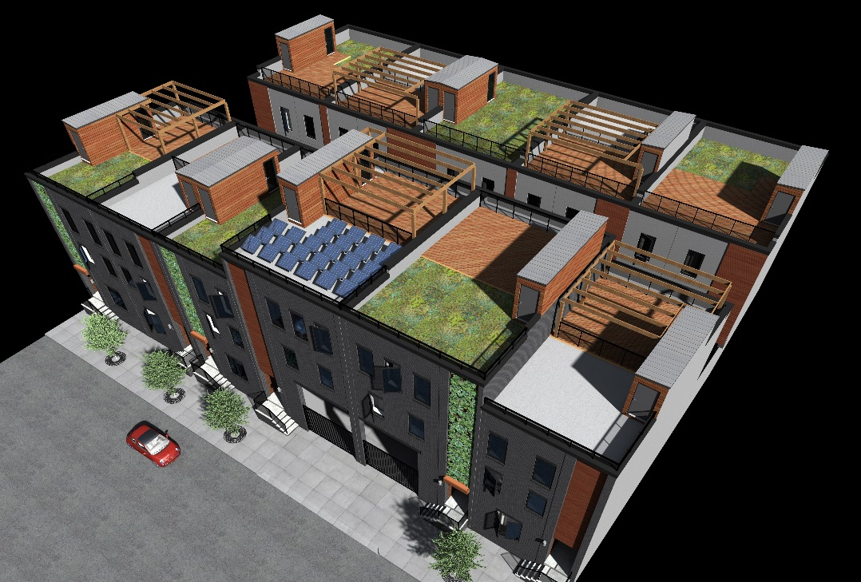

* Clicking picture leads to website: <http://moyerstreetcourt.com>

1. Wharton Street Lofts – Green Roof

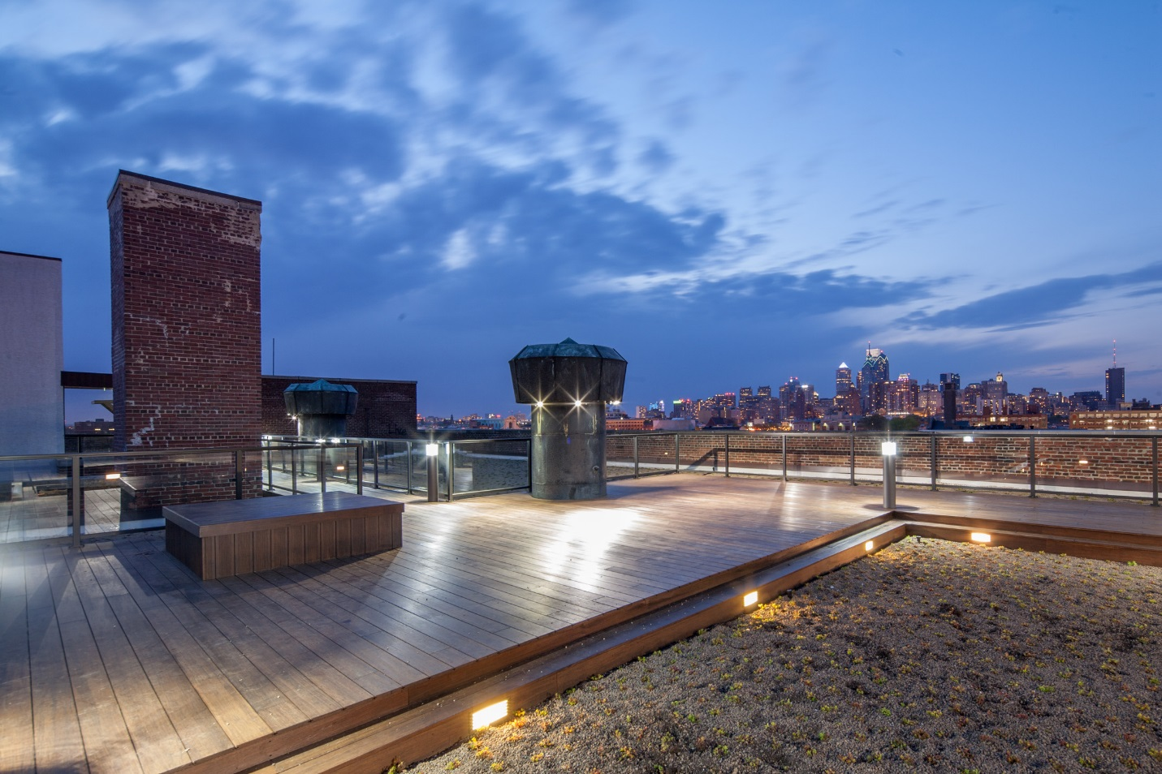

* Clicking picture leads to website: <http://www.whartonstreetlofts.com/gallery>